**NATIONAL UNIVERSITY OF COMPUTER AND EMERGING SCIENCES**

**PROGRAM: SOFTWARE ENGINEERING**



***WEB ENGINEERING LAB***

**LAB TASK 02**

**SUBMITTED BY:**

**Name: Ahmed Ali**

**Roll No: 22P-9318**

**Section: BS(SE)-6B**

**INSTRUCTOR NAME: Sir Zakria**

**A DEPARTMENT OF COMPUTER SCIENCE**

**CODE OF QUESTION 1:**

<!DOCTYPE html>

<html>

<head>

<title>Lab Task 2</title>

<meta charset="UTF-8">

</head>

<body>

<h2 style="text-align: center; color: red;">REGISTERATION FORM</h2>

<form>

<table border="1" cellspacing="0" cellpadding="5" align="center" width="50%">

<tr>

<th colspan="2">INFORMATION TABLE</th>

</tr>

<tr>

<td width="50%">Name</td>

<td><input type="text" name="name"><br>Enter you full name</td>

</tr>

<tr>

<td>Email</td>

<td><input type="email" name="email"><br>Enter internet contact address</td>

</tr>

<tr>

<td>Password</td>

<td><input type="password" name="password"><br>Enter a code to identify you</td>

</tr>

<tr>

<td>Address</td>

<td><input type="text" name="address"><br>ENter complete address</td>

</tr>

<tr>

<td>Country</td>

<td>

<select placeholder="country">

<option value="">country</option>

</select>

</td>

</tr>

<tr>

<td>Gender</td>

<td>

<input type="radio" name="gender" value="male">Male

<input type="radio" name="gender" value="female">Female

</td>

</tr>

<tr>

<td>Hobbies</td>

<td>

<input type="checkbox" name="hobbies" value="reading">Reading<br>

<input type="checkbox" name="hobbies" value="music">Listening Music<br>

<input type="checkbox" name="hobbies" value="gardening">Gardening<br>

<input type="checkbox" name="hobbies" value="swimming">Swimming<br>

<input type="checkbox" name="hobbies" value="athletics">Athletics<br>check all that apply

</td>

</tr>

<tr>

<td>Your Website</td>

<td><input type="url" name="website" placeholder="http://"><br>provide your website URL if exist (not necessary) </td>

</tr>

<tr>

<td>Other Information About You</td>

<td>

<textarea name="other_info" rows="4" cols="40"></textarea><br>write any other information that is not present here

</td>

</tr>

<tr>

<th colspan="2">Send Details</th>

</tr>

<tr>

<td></td>

<td colspan="2" style="text-align: left;">

<input type="submit" value="SEND">

<input type="reset" value="RESET">

</td>

</tr>

</table>

</form>

</body>

</html>

**SCREENSHOT: OUTPUT OF Q1;**

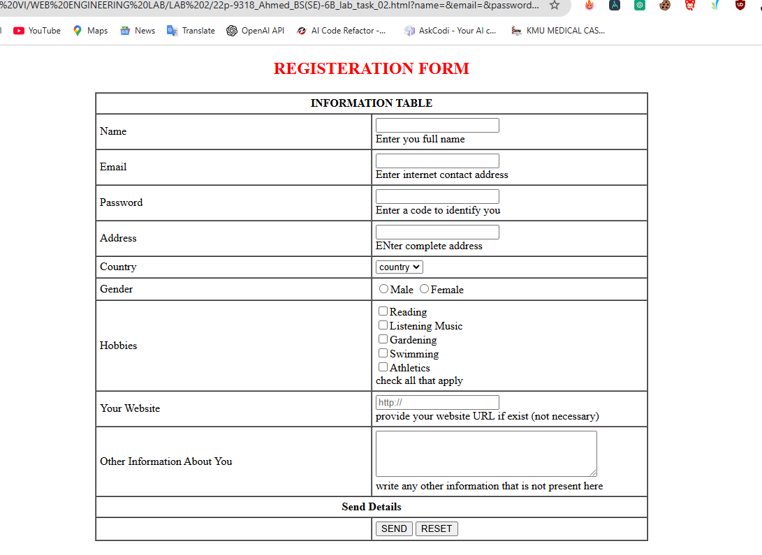

**CODE OF QUESTION 2:**

<!DOCTYPE html>

<html>

<head>

<title>Lab Task 2 problem 2</title>

</head>

<body>

<table border="1" width="50%" cellspacing="0" cellpadding="10" align="center">

<tr bgcolor="#d7e1bc">

<td colspan="2" align="left"><h1>Site Name</h1></td>

</tr>

<tr bgcolor="#ffeada">

<td colspan="2" align="left">

Home | About Us | Gallery | FAQ | Contact Us

</td>

</tr>

<tr>

<td width="75%">

<h2>Welcome to our Website</h2>

<p>

Lorem ipsum dolor sit amet, consectetur adipisicing elit, sed do eiusmod tempor incididunt ut labore et dolore magna aliqua. Ut enim ad minim veniam, quis nostrud exercitation ullamco laboris nisi ut aliquip ex ea commodo consequat. Duis aute irure dolor in reprehenderit in voluptate velit esse cillum dolore eu fugiat nulla pariatur. Excepteur sint occaecat cupidatat non proident, sunt in culpa qui officia deserunt mollit anim id est laborum.

</p>

<p>

Etiam dapibus porttitor sodales. Nulla vestibulum mauris nec lorem fermentum, quis fringilla lectus pellentesque. Nunc auctor scelerisque ex eget porttitor. Maccenas in ultricies tortor. Sed id laoreet urna, ac viverra sem. Nunc tincidunt consectetur enim, aliquet rhoncus odiodictum vitae. In quis eros dolor.

</p>

</td>

<td width="30%" valign="top">

<ul type="">

<li>Home</li>

<li>About Us</li>

<li>Gallery</li>

<li>FAQ</li>

<li>Contact Us</li>

</ul>

</td>

</tr>

<tr bgcolor="#8a936e">

<td colspan="2" align="left">

Copyright Sitename@2018

</td>

</tr>

</table>

</body>

</html>

**SCREENSHOT: OUTPUT OF Q2;**

